Biopsychology
Exam I

Name

In some of the sections below, you have a choice of questions to answer. When the instructions say
“Please answer ANY TWO of the following THREE questions” or “Please answer ANY FOUR of the following SIX questions” please do only that. If you answer more than the required number, I will grade the answered questions in that section in order up to the requested number of answers, and will not grade additional questions beyond that.

Section I
Genetics and Evolution (1 point each)

- When mitosis occurs, both daughter cells end up with:
- both daughter cells end up with a full complement of chromosomes
- both daughter cells end up with half the full complement of chromosomes
- a gamete is produced
- the sex of the individual is determined
- molecules pass through the blood brain barrier
- more than of the above

- Briefly define a "dichotomous" trait.
__________________________________________________________________________________
__________________________________________________________________________________
__________________________________________________________________________________
__________________________________________________________________________________

- Provide a brief definition of the term "gene".
__________________________________________________________________________________
__________________________________________________________________________________
__________________________________________________________________________________
__________________________________________________________________________________

- Provide brief definitions of the terms "phenotype" and “genotype”.
__________________________________________________________________________________
__________________________________________________________________________________
__________________________________________________________________________________
__________________________________________________________________________________

- According to Darwin, "fitness" is
- the amount of time one spends at "curves"
- the ability of an organism to survive
- eating only fruits and vegetables forever
- the ability for an organism to contribute its genes to the gene pool of the next generation?

- Pinel feels one cannot easily establish which proportion of a behavior is caused by genes (nature) and which is caused by environment (nurture) and thus that the nature/nurture argument is flawed. Briefly explain this.
__________________________________________________________________________________
__________________________________________________________________________________
__________________________________________________________________________________
__________________________________________________________________________________

Please answer ANY TWO of the following THREE questions. (1 points each)

- Who was Charles Darwin? When did he live? What was his occupation? What was his contribution to the field of evolution?
__________________________________________________________________________________
__________________________________________________________________________________
__________________________________________________________________________________
__________________________________________________________________________________

- T or F: "Individuals evolve"? Explain.
__________________________________________________________________________________
__________________________________________________________________________________
__________________________________________________________________________________
__________________________________________________________________________________

- Briefly, explain why we bother to talk about evolution in a Biopsychology Course.
__________________________________________________________________________________
__________________________________________________________________________________
__________________________________________________________________________________
__________________________________________________________________________________

Please answer ANY TWO of the following THREE questions. (1 points each)

- Briefly describe the relationship between chromosomes, DNA, and genes.
__________________________________________________________________________________
__________________________________________________________________________________
__________________________________________________________________________________
- Briefly compare Meiosis and Mitosis (be sure to include in your answer the function of each type of cell division)
__________________________________________________________________________________
__________________________________________________________________________________
__________________________________________________________________________________
__________________________________________________________________________________

- Briefly explain why we should care about genes in a biopsychology course?
__________________________________________________________________________________
__________________________________________________________________________________
__________________________________________________________________________________
__________________________________________________________________________________

Functional Anatomy of the Nervous System

Match the following (1 point each)
____ Conducting region of neuron located between the soma and terminal | a. cell membrane
____ Separates the inside of the cell from the outside environment | b. synapse
____ Fatty insulation | c. myelin
____ Specialized connection site between neurons | d. axon

Answer the following questions (1 point each):

- Circle the structures that comprise the brain stem:
medulla midbrain
diencephalon cerebral hemispheres
cerebellum pons
thalamus

- What is meant by "functional organization" of the brain (i.e., localization of function)?
__________________________________________________________________________________
__________________________________________________________________________________
__________________________________________________________________________________
__________________________________________________________________________________

- Briefly define afferent and efferent as it relates to information flow in the nervous system.
__________________________________________________________________________________
__________________________________________________________________________________
__________________________________________________________________________________
__________________________________________________________________________________

Consider the following diagram and fill in the name of the boxes representing the different areas of the nervous system (use the names listed below the flow chart, 1 point each):

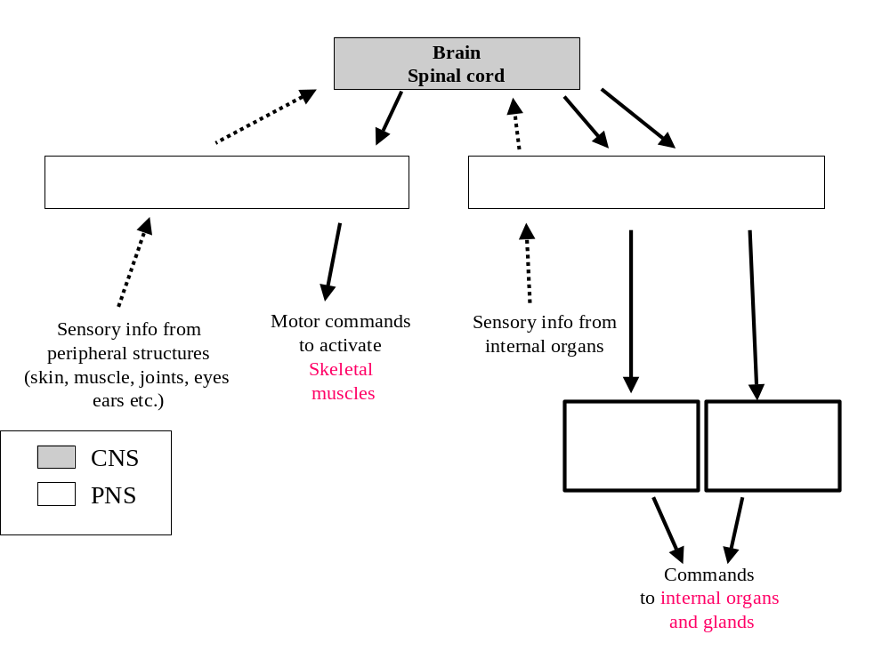
- match the labels below with the appropriate boxes in the diagram above (1 point each)
- Somatic division of PNS
- Autonomic division PNS
- Sympathetic branch
- Parasympathetic branch

The Neuron
Please label each external structure of the neuron. (1 point each)

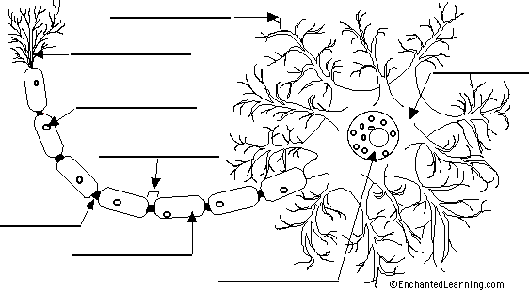

List and provide a description of the function of at least five major internal structures of a neuron
(2 points).
__________________________________________________________________________________
__________________________________________________________________________________
__________________________________________________________________________________
__________________________________________________________________________________
__________________________________________________________________________________
__________________________________________________________________________________
__________________________________________________________________________________
__________________________________________________________________________________
__________________________________________________________________________________
__________________________________________________________________________________
__________________________________________________________________________________
__________________________________________________________________________________
Answer the following questions (1 point each):

- When a neuron is at rest, Sodium, potassium and calcium are ions that are higher in concentration on
the outside of neurons (compared with their intracellular concentration).
True or False (circle one)

- What is the difference between an IPSP and an EPSP.
__________________________________________________________________________________
__________________________________________________________________________________
__________________________________________________________________________________
__________________________________________________________________________________
__________________________________________________________________________________

- __________ is the ion that is associated with the rising phase of the action potential and __________ is associated with the falling phase of the action potential.

Below is a graph showing an action potential recorded from a typical neuron.

- Identify lines labeled A., B., and C on the graph below (2 points)
- Explain in detail the different phases and what is taking place during the phases. Make sure to explain what ions are present and how they change during each phase. (5 points).

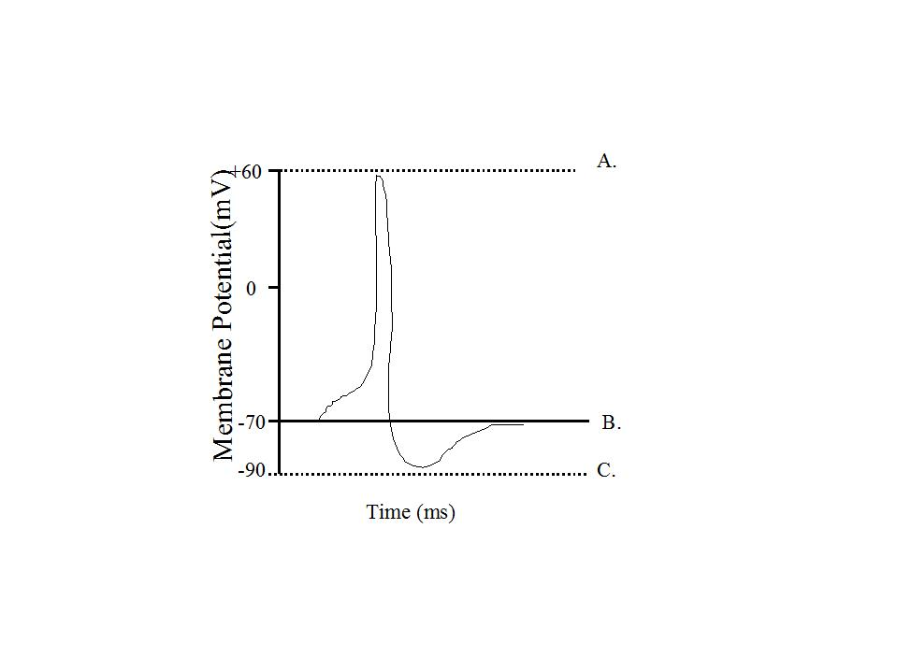
__________________________________________________________________________________
__________________________________________________________________________________
__________________________________________________________________________________
__________________________________________________________________________________
__________________________________________________________________________________
__________________________________________________________________________________
__________________________________________________________________________________
The Eye
Please label each part of the eye. (1 point each)

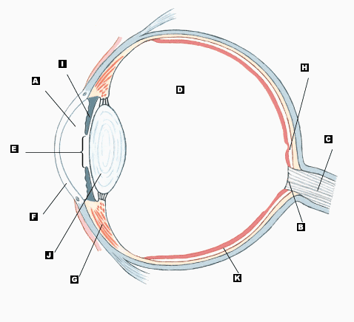

A. F.
B. G.
C. H.
D. I.
E. J.
K.

Please answer ANY FOUR of the following SIX questions. Make sure to answer the question and do not stray. Make sure to write in complete sentences and answer the questions directly.
(2 points each)

- What are the M and pathways in the brain?
__________________________________________________________________________________
__________________________________________________________________________________
__________________________________________________________________________________
__________________________________________________________________________________

- Provide a short description of the two types of photoreceptors?
__________________________________________________________________________________
__________________________________________________________________________________
__________________________________________________________________________________
__________________________________________________________________________________

- Explain light and dark adaptation.
__________________________________________________________________________________
__________________________________________________________________________________
__________________________________________________________________________________
__________________________________________________________________________________

- I mentioned reasons why information that falls on the fovea is seen more clearly. What is the fovea, and why is information that lands on this area seen most clearly?
__________________________________________________________________________________
__________________________________________________________________________________
__________________________________________________________________________________
__________________________________________________________________________________

- Explain neural convergence in the eye?
__________________________________________________________________________________
__________________________________________________________________________________
__________________________________________________________________________________
__________________________________________________________________________________

- Outline the major pathway for vision, tracing the information from the eye to the primary visual centers of the brain.
__________________________________________________________________________________
__________________________________________________________________________________
__________________________________________________________________________________
__________________________________________________________________________________

The Brain
Please label each part of the brain. (1 point each)

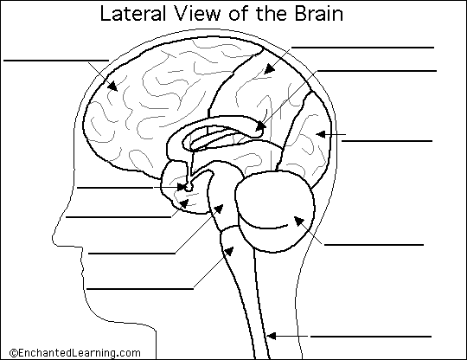

Please explain the roles of each of the structures you labeled. (5 points)
__________________________________________________________________________________
__________________________________________________________________________________
__________________________________________________________________________________
__________________________________________________________________________________
__________________________________________________________________________________
__________________________________________________________________________________
__________________________________________________________________________________
__________________________________________________________________________________
__________________________________________________________________________________
__________________________________________________________________________________
__________________________________________________________________________________
__________________________________________________________________________________
__________________________________________________________________________________

Section II
Multiple choice questions. (1 point each)

- The advantage of using laboratory animals instead of humans as subjects in biopsychological research is that
- their brains are more simple.
- there are fewer ethical restrictions on their study.
- they are incapable of communication.
- all of the above
- both a and b

- The major problem in interpreting case studies has to do with their
- generalizability.
- ethics.
- neurotoxic effects.
- correlations.
- purity.

- Using two or more different research approaches to make a scientific discovery that could not have been made using a single approach alone is called
- scientific inference.
- converging operations.
- scientific lordosis.
- confounding operations.
- none of the above

- In humans, all of the visual receptors are in the
- last layer of the retina to be reached by light entering the eye.
- first layer of the retina to be reached by light entering the eye.
- cornea.
- middle layer of the retina.
- optic disk.

- Humans without rods experience
- night blindness.
- color blindness.
- day blindness.
- both a and b.
- both b and c.

- The principle that precedence should be given to the most simple interpretation of a behavior when more than one interpretation is possible is called
- the principle of precedence.
- the principle of simplicity.
- Delgado's canon.
- the principle of convergence.
- Morgan's canon.

- The reason why radioactive 2-DG is useful for revealing the level of activity of neurons in different parts of the brain is that 2-DG
- is absorbed by neurons in relation to their level of activity.
- is metabolized by neurons in relation to their level of activity.
- is not metabolized by neurons.
- both a and c.
- both a and b.

- The relay station for information flowing into and out of the higher brain centers is the:
- hippocampus
- hypothalamus
- reticular formation
- thalamus

- A ceiling effect occurs when a measure is too
- easy
- difficult
- variable
- sensitive

- Which of the following best describes way information on the fovea is seen most clearly.
- it does not pass through as many layers in the retina.
- it hits the fovea before hitting the vitreous humor.
- it gets processed faster in the occipital lobe.
- there is less data reduction.
- both a and d.

- If you were startled by a loud noise, there would be an increase in your skin's conductance of electricity. This response is called
- a skin conductance response.
- an EKG.
- a skin conductance level.
- an average evoked potential.
- a P300 wave.

- The P300
- is a negative EEG wave.
- is a far-field potential occurring 300 mm from the electrode.
- occurs about 300 seconds prior to a response.
- is a component of the potential evoked by a meaningless click.
- is an EEG wave that often occurs after the presentation of a momentary stimulus meaningful to the subject.

- The digit-span test is the most commonly used test of
- short-term memory.
- counting.
- arithmetic.
- intelligence.
- lateralization.

- According to the cognitive neuroscientific approach
- each complex cognitive process is composed of a number of simple processes.
- each simple cognitive process is mediated by an area of the brain
- using a subtractive image approach areas that control simple processes can be identified
- none of the above.
- all of the above.

- In humans, the primary visual cortex is in the _______ lobe.
- frontal
- parietal
- occipital
- temporal
- optic disk

- One major advantage of a using event related potentials as a measure in psychological research is that:
- no overt response is required by the subject
- brain waves never lie
- subjects are required to provide more descriptive commentary
- all of the above are advantages
- there are no advantages to this method

- Within the limbic system the structure thought to play a major role in memories is?
- the septum
- the paricturalis
- the thalamus
- the hippocampus
- none of the above.

- Light passes through layers of the retina in which of the following sequences?
- receptor layer, bipolar cell layer, retinal ganglion cell layer
- retinal ganglion cell layer, horizontal cell layer, receptor layer
- retinal ganglion cell layer, amacrine cell layer, receptor layer
- both b and c.
- none of the above.

- High-acuity, color vision is mediated by only the small foveal area of the retina. Nevertheless, we have perceptions of the world that are expansive in both their color and their detail. This is possible because
- of the optic disks.
- of retinal disparity.
- of the difference between the photopic and scotopic spectral sensitivity curves.
- we have depth perception.
- our visual systems integrate the foveal images from several different visual fixations to produce the subjective visual perception that we are experiencing at any instant.

- Transduction refers to the
- perception of lights.
- disappearance of visual stimuli.
- transmission of sensory signals to the cortex.
- transmission of visual signals to the cortex.
- translation of one form of energy to another.

- The bleaching of rhodopsin
- depolarizes rods.
- depolarizes cones.
- opens Na+ channels.
- both a and c.
- hyperpolarizes rods.

- The retina-geniculate-striate system is organized
- from top to bottom.
- from left to right.
- on the basis of wavelength.
- retinotopically.
- both a and b.

- The pituitary gland is attached to which brain structure?
- cerebellum
- medulla
- thalamus
- hypothalamus

- The brain structure that controls heart rate, breathing, and blood pressure is the:
- reticular formation
- thalamus
- cerebellum
- medulla

- Your car speedometer fluctuates between 15 and 60 miles per hour as you are driving on the freeway at a constant speed. As a measure of speed, your speedometer is low in:
- reliability
- validity
- reactivity
- all of the above

Section III
Essay/Short answer

Please answer ANY FOUR of the following SIX questions. Make sure to answer the question and do not stray. Make sure to write in complete sentences and answer the questions directly.
(2 points each)

- What are advantages to the blood-brain barrier? What are disadvantages to the blood-brain barrier?
__________________________________________________________________________________
__________________________________________________________________________________
__________________________________________________________________________________
__________________________________________________________________________________
__________________________________________________________________________________

- Provide a description of neurotransmitters; what are they, what do they do, how do they work? Next, tell me at least two different neurotransmitters that are important for Biopsychologists.
__________________________________________________________________________________
__________________________________________________________________________________
__________________________________________________________________________________
__________________________________________________________________________________
__________________________________________________________________________________

- Provide a description of at least 5 ways that drugs can alter synaptic transmission.
__________________________________________________________________________________
__________________________________________________________________________________
__________________________________________________________________________________
__________________________________________________________________________________
__________________________________________________________________________________

- Is it true that we only use 10 percent of our brain? If so, what does that mean? If not, why not?
__________________________________________________________________________________
__________________________________________________________________________________
__________________________________________________________________________________
__________________________________________________________________________________

- Please explain the similarities and differences between MRI and fMRI. Next, explain two different techniques for imaging the human brain.
__________________________________________________________________________________
__________________________________________________________________________________
__________________________________________________________________________________
__________________________________________________________________________________

- What does the myelin sheath of the axon accomplish? Why type of axon is more likely to be myelinated, and why?
__________________________________________________________________________________
__________________________________________________________________________________
__________________________________________________________________________________
__________________________________________________________________________________

